
Assignment No. : 06

Name : Aditya Latke
PRN : 1262252462
DIV : 1

PROBLEM STATEMENT:Write a C function to compute the factorial of a number with and without recursion.

OBJECTIVE:

To demonstrate two different approaches for calculating the factorial of a number: iterative (non-recursive) and recursive, showcasing the versatility of problem-solving methods in programming.

THEORY:
1) Explain the difference between the iterative and recursive approaches to calculating the factorial of a number.
Difference between Iterative and Recursive approaches (Factorial):
- Iterative approach: Uses a loop to repeatedly multiply numbers from 1 to n to compute n!. It is more efficient in terms of time and memory, as it does not involve function calls.
- Recursive approach: Defines factorial as n! = n × (n−1)! and calls itself until a base case (0! = 1) is reached. It is simpler but uses more memory due to function call overhead and may lead to stack overflow for large n.

2) What is the base case in the recursive function for computing factorials, and why is it necessary?
The base case is: 0! = 1 (sometimes also written as 1! = 1). It is necessary because the base case stops the recursion. Without it, the function would keep calling itself indefinitely, leading to a stack overflow error. It provides a definite value so that all previous recursive calls can be resolved and the final result can be computed.

3) How does the program handle invalid input, such as negative numbers, and why is this important?
A factorial is defined only for non-negative integers. To handle invalid input like negative numbers, the program should include a check at the beginning:
if (n < 0) {
printf("Invalid input");
return -1; // or handle error appropriately
}
This is important because it:
- Prevents incorrect or undefined results (factorial of a negative number does not exist).
- Avoids infinite recursion in recursive approaches.
- Makes the program more reliable and user-friendly by handling errors properly.

PLATFORM: Linux

INPUT:

Without Recursion(Iterative):
Program:
#include <stdio.h>

int factorial(int n) {
int result = 1;
for(int i = 1; i <= n; i++) {
result *= i;
}
return result;
}

int main() {
int n;
printf("Enter a number: ");
scanf("%d", &n);

if(n < 0) {
printf("Invalid input\n");
} else {
printf("Factorial = %d\n", factorial(n));
}

return 0;
}

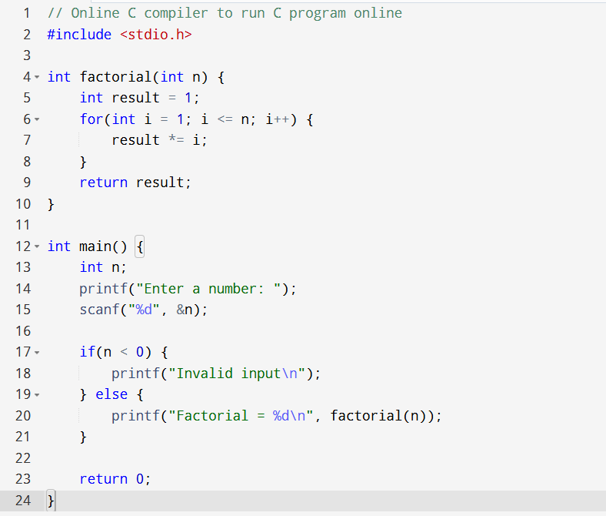

OUTPUT:
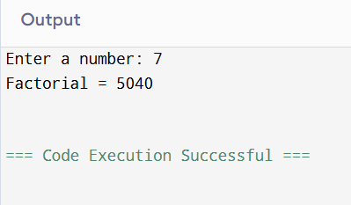

CONCLUSION: Thus, we have successfully executed factorial of a number with and without recursion.

FAQs:
1. What is the purpose of calculating factorial in programming?
2. What is the difference between recursive and non-recursive (iterative) methods?

